**RUST**

**Introduction**

* **Rust** is **open-source** & **standalone** programming language.
* **Standalone language:** A language that works **without** any framework.
* It is also **platform independent** & thus portable across various OS.

**Basic Information**

* **Rust** uses **package manager** called **cargo**.
* It requires you to install **Visual C++** also.
* The user needs to add: ***%USERPROFILE%\.cargo\bin***

**Working With Command Prompt**

**For getting help –>**



**Creating a program/project –>**

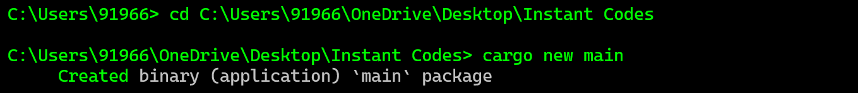

**Running the .rs file –>**

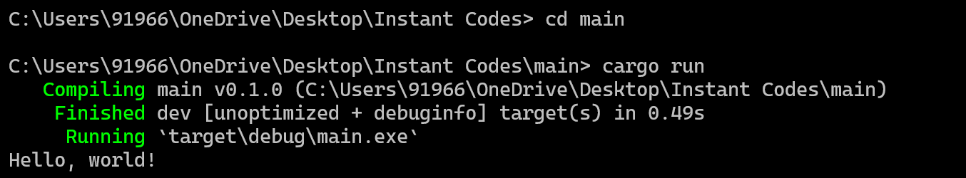

**Inside created folder (main) –>**

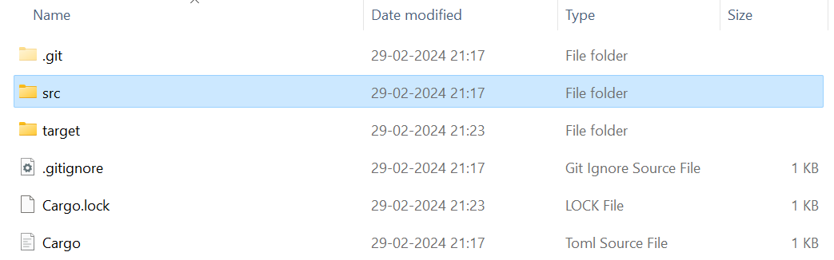

* Folder **src** contains the ***.rs*** file.
* And this ***.rs*** file contains the ***“Hello, World!”*** code by default.